Chapter one

Introduction

Robotics has achieved its greatest success to date in the world of industrial manufacturing. Robot arms, or manipulators, comprise a 2 billion dollar industry. Bolted at its shoulder to a specific position in the assembly line, the robot arm can move with great speed and accuracy to perform repetitive tasks such as spot welding and painting (figure 1.1). In the electronics industry, manipulators place surface mounted components with superhuman precision, making the portable telephone and laptop computer possible.

Yet, for all of their successes, these commercial robots suffer from a fundamental disadvantage: lack of mobility. A fixed manipulator has a limited range of motion that depends on where it is bolted down. In contrast, a mobile robot would be able to travel throughout the manufacturing plant, flexibly applying its talents wherever it is most effective.

The technology of mobility: how can a mobile robot move unsupervised through real-world environments to fulfill its tasks? The first challenge is locomotion itself. How should a mobile robot move and what is it about a particular locomotion mechanism that makes it superior to alternative locomotion mechanisms?
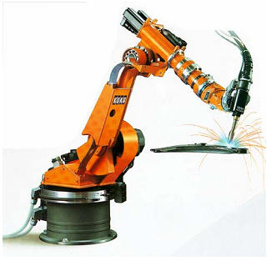

Figure 1.1
Picture of auto assembly plant-spot welding robot of KUKA

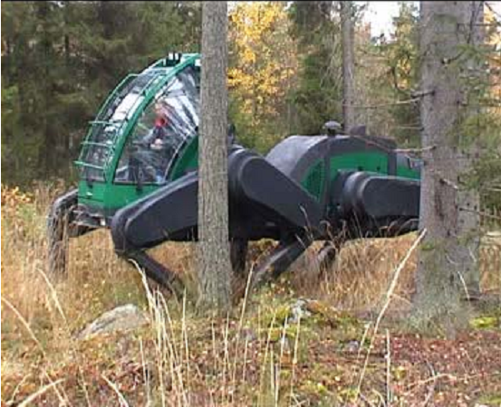
Figure 1.2
Plustech developed the first application-driven walking robot. It is designed to move wood out of the
forest. The leg coordination is automated, but navigation is still done by the human operator on the
robot.

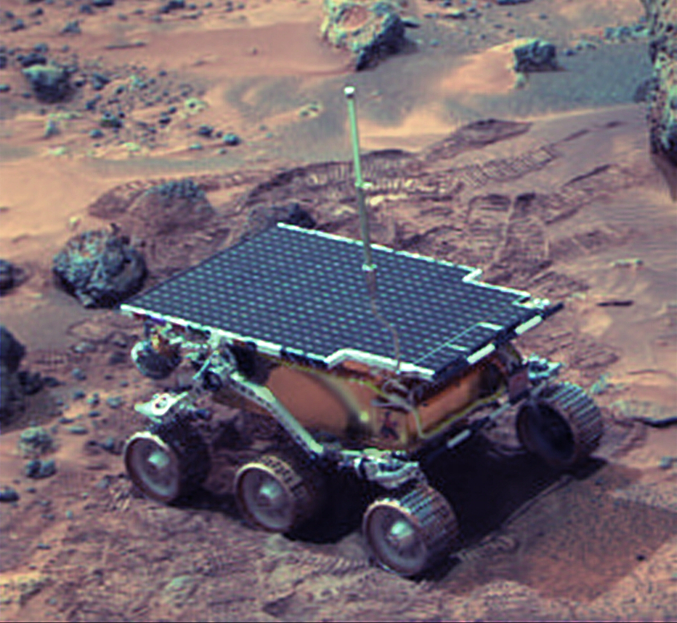
Figure 1.3
The mobile robot Sojourner was used during the Pathfinder mission to explore Mars in summer 1997. © NASA/JPL

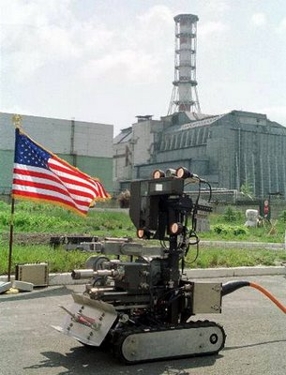
Figure 1.4
Picture of Pioneer, a robot designed to explore the Sarcophagus at Chernobyl. © Wide World Photos.

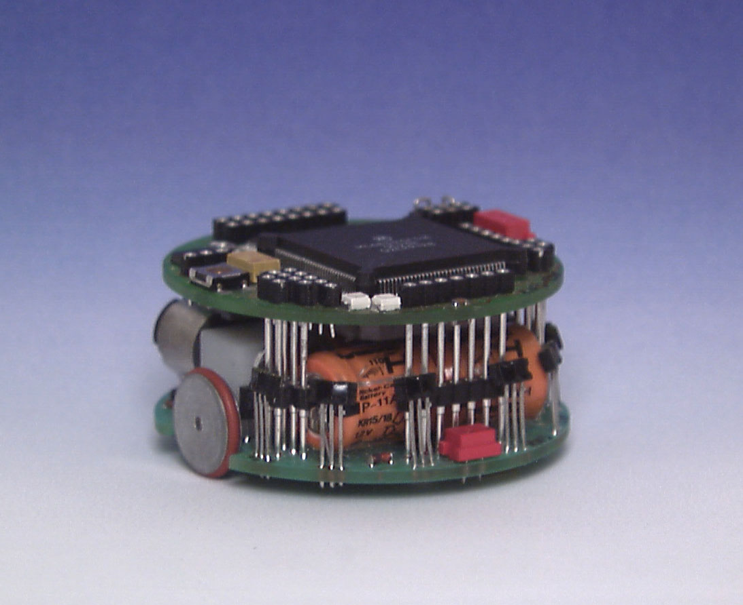
Figure 1.5
KHEPERA is a small mobile robot for research and education. It is only about 60 mm in diameter.
Various additional modules such as cameras and grippers are available. More then 700 units had
already been sold by the end of 1998. KHEPERA is manufactured and distributed by K-Team SA,

Flow Chart 1.1 Applications of Mobile Robots

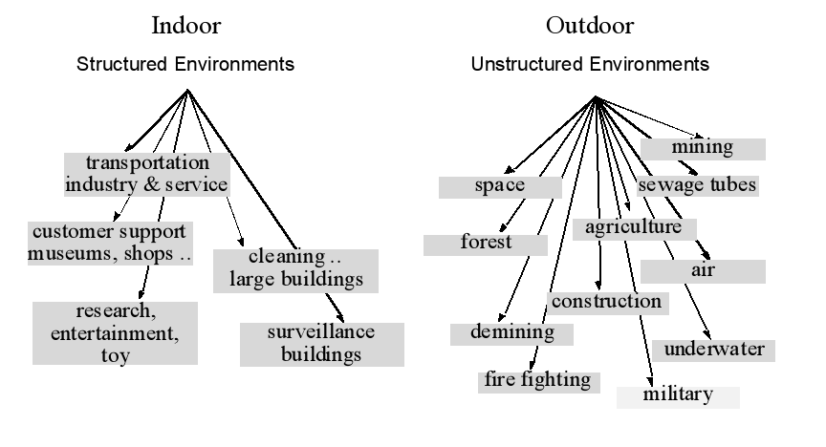

Chapters 2, "Robotics", begins with definition of robot and then explain basic control methods, the common and effective solution that is used at robotics control is a negative feedback loop. The second control method is open loop control; this method will work reliably only when the robot is very predictable. The third method is feed forward control.

Then it survey at types of robots as Industrial Robots, Military Robots, Space Robots, Fun/Toy Robots and ……others.

Chapter 3, "Construction of Robots", explain what the robot's bodies consist of, beginning with structural materials, then give overview about arms and grippers that can be used at robots. The arms types such as Revolute Coordinate arm, Polar Coordinate arm, Cartesian Coordinate arm and Cylindrical Coordinate arm. The grippers types such as Two-Pincher Gripper and One –pincher gripper.

Then it illustrates a survey of the most popular mechanisms that enable locomotion: wheels and legs. But it focuses on the wheeled robots and illustrates the types and the specification of all wheels that is used in the manual robot and automatic robots.
The power in the robot is supported by batteries, so the batteries types and the batteries that are used in the robots explain at chapter 3.

The different between motors types is explained at chapter 3 and it focus on DC motors with explaining its operation briefly.
Chapter 4, "Manual Robot", for the manual robot, we used relays for control so we will explain the basics of relays, how it works, how to select the right relay, and its advantages and disadvantages.

Also for driving the motors we used H-BRIDGE circuits so we described how this circuit works, and our modified H-BRIDGE circuit.
Finally we introduced our control circuits that we used in controlling the manual robot as schematics and layouts by using ORCAD; also we introduced our user controller interface which is a play station joy stick.

Chapter 5, "Automatic Robots", control at automatic robot is built in PLC technology so this chapter beginning with overview about the PLC, Comparison of PLC with other control system and advantage of PLC over the other control system.
There are many types of PLCs that can be used and we choose FATEK FBS Series to use for automatic robot control, chapter 5 explains the feature of FATEK FBS Series and the inputs that are used in the automatic robots such as :-
1-on-off switches
2-limit switches
3-color mark sensor
4-proximity sensors
5- Retroflective sensor.

The control technique is explained at details; firstly explain the plan of motion control
With illustrating about how using Pulse width modulation (PWM) technique at motors control to support the motion control, then explain the sensors that are used to make the motion control, secondly explain the rotation and arm control, then the method of wiring and the components that are used are explained.

The programs of the first and second automatic robot is write and explained in details in this chapter with an overview about Instruction lists of FATEK FBs Series.

